HTML Comments

💬 Definition
# Source: AI Source: Provided by: [Data Path: Persons Table -> ID Column: 1, Name_En Column: Motasem Essam] -> From: [ChatGPT] on [5/6/2026]
HTML comments are notes written inside HTML code that are not displayed in the browser. They are used to explain, organize, or temporarily disable parts of code.

🧱 Syntax of HTML comments
# Source: AI Source: Provided by: [Data Path: Persons Table -> ID Column: 1, Name_En Column: Motasem Essam] -> From: [ChatGPT] on [5/6/2026]
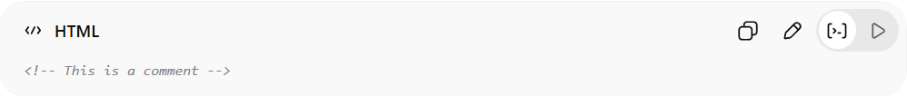
<!-- This is a comment -->
- Starts with: <!--
- Ends with: -->
- Anything inside is ignored by the browser

🧠 Simple example

Full Example
# Source: AI Source: Provided by: [Data Path: Persons Table -> ID Column: 1, Name_En Column: Motasem Essam] -> From: [ChatGPT] on [5/6/2026]
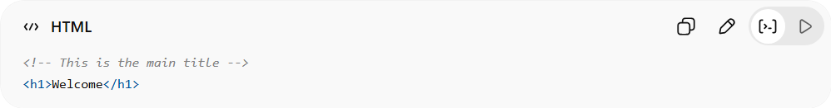
<!-- This is the main title -->
<h1>Welcome</h1>
👉 The comment is not visible on the webpage
👉 Only developers can see it in the code

Real Example
# Source: ScreenShot Source: Provided by: [Persons Table -> ID Column: 1, Name_En Column: Motasem Essam] -> Tool: [Automation Table -> ID Column: 16, Name_En Column: Screen Capture] -> From [Operating System: Windows] on [5/6/2026]
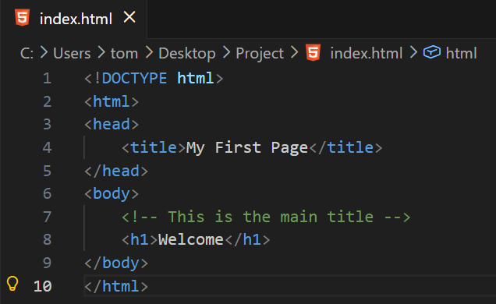
<!DOCTYPE html>
<html>
<head>
<title>My First Page</title>
</head>
<body>
<!-- This is the main title -->
<h1>Welcome</h1>
</body>
</html>
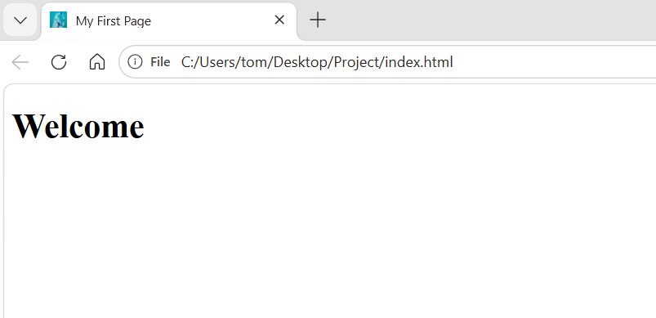

🛠️ Uses of HTML comments
# Source: AI Source: Provided by: [Data Path: Persons Table -> ID Column: 1, Name_En Column: Motasem Essam] -> From: [ChatGPT] on [5/6/2026]
- 📝 Explain code
- 🧩 Organize sections
- 🚫 Temporarily disable code
- 👨‍💻 Help teams understand code

📝 1. Explain Code
# Source: AI Source: Provided by: [Data Path: Persons Table -> ID Column: 1, Name_En Column: Motasem Essam] -> From: [ChatGPT] on [5/6/2026]
📖 Description:
Used to describe what a part of the code does.
❌ Without comment:
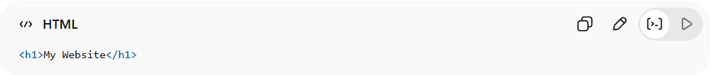
<h1>My Website</h1>
✅ With comment:
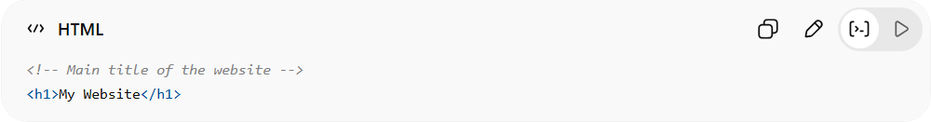
<!-- Main title of the website -->
<h1>My Website</h1>

🧩 2. Organize Code Sections
# Source: AI Source: Provided by: [Data Path: Persons Table -> ID Column: 1, Name_En Column: Motasem Essam] -> From: [ChatGPT] on [5/6/2026]
📖 Description:
Helps divide code into clear sections (header, footer, etc.).
❌ Bad (no structure):
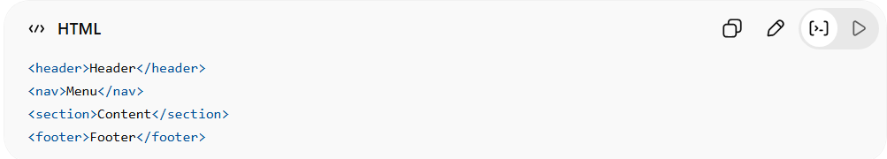
<header>Header</header>
<nav>Menu</nav>
<section>Content</section>
<footer>Footer</footer>
✅ Good:
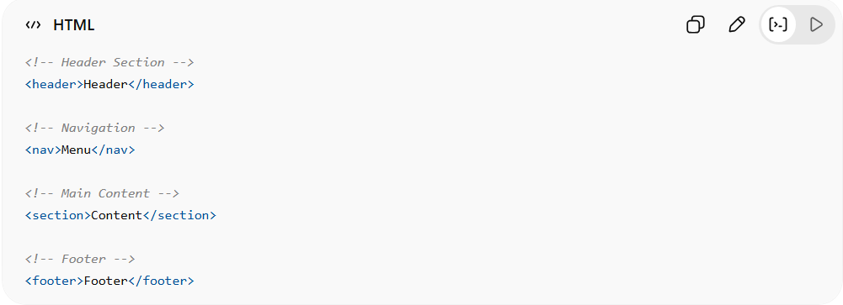
<!-- Header Section -->
<header>Header</header>
<!-- Navigation -->
<nav>Menu</nav>
<!-- Main Content -->
<section>Content</section>
<!-- Footer -->
<footer>Footer</footer>

🚫 3. Disable Code (Temporary)
# Source: AI Source: Provided by: [Data Path: Persons Table -> ID Column: 1, Name_En Column: Motasem Essam] -> From: [ChatGPT] on [5/6/2026]
📖 Description:
Used to hide code without deleting it.
❌ Bad (deleted code):
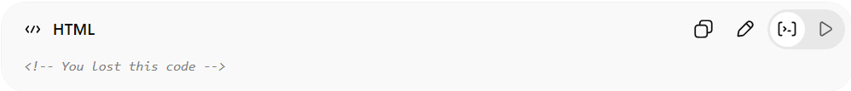
<!-- You lost this code -->
✅ Good:
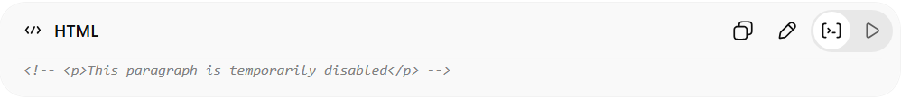
<!-- <p>This paragraph is temporarily disabled</p> -->

👨‍💻 4. Help Team Collaboration
# Source: AI Source: Provided by: [Data Path: Persons Table -> ID Column: 1, Name_En Column: Motasem Essam] -> From: [ChatGPT] on [5/6/2026]
📖 Description:
Used to leave notes for other developers.
❌ Bad (no explanation):
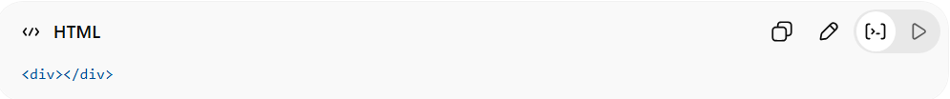
<div></div>
✅ Good:
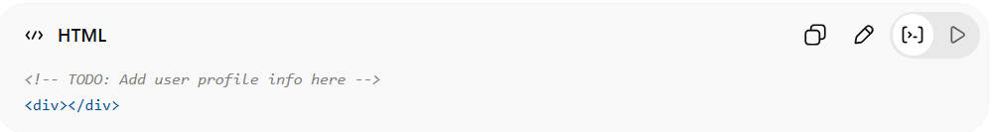
<!-- TODO: Add user profile info here -->
<div></div>

⚠️ Rules for comments
# Source: AI Source: Provided by: [Data Path: Persons Table -> ID Column: 1, Name_En Column: Motasem Essam] -> From: [ChatGPT] on [5/6/2026]
- ❌ Do not nest comments
- ❌ Avoid sensitive information inside comments
- ✔ Keep comments short and useful

⚠️ 1. Do Not Nest Comments
# Source: AI Source: Provided by: [Data Path: Persons Table -> ID Column: 1, Name_En Column: Motasem Essam] -> From: [ChatGPT] on [5/3/2026]
📖 Description:
HTML does not support comments inside comments.
❌ Bad:
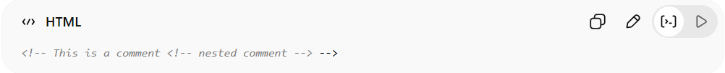
<!-- This is a comment <!-- nested comment --> -->
✅ Good:
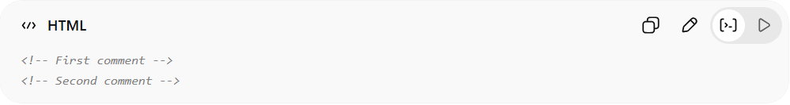
<!-- First comment -->
<!-- Second comment -->

❌ 2. Avoid Sensitive Information
# Source: AI Source: Provided by: [Data Path: Persons Table -> ID Column: 1, Name_En Column: Motasem Essam] -> From: [ChatGPT] on [5/6/2026]
📖 Description:
Comments are visible in the page source 👉 Anyone can view this in the browser → security risk, so never include private or secure data.
❌ Bad (unsafe):
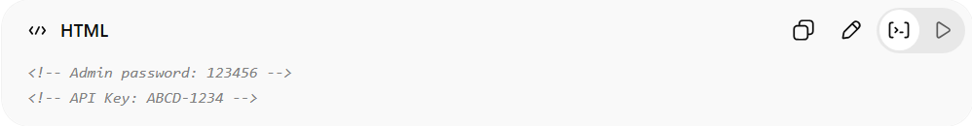
<!-- Admin password: 123456 -->
<!-- API Key: ABCD-1234 -->
👉 Anyone can view this in the browser → security risk
✅ Good:
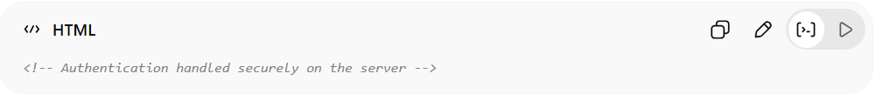
<!-- Authentication handled securely on the server -->

✔ 3. Keep Comments Short and Useful
# Source: AI Source: Provided by: [Data Path: Persons Table -> ID Column: 1, Name_En Column: Motasem Essam] -> From: [ChatGPT] on [5/6/2026]
📖 Description:
Comments should be clear and concise, not long or
unnecessary.
❌ Bad (too long and useless):
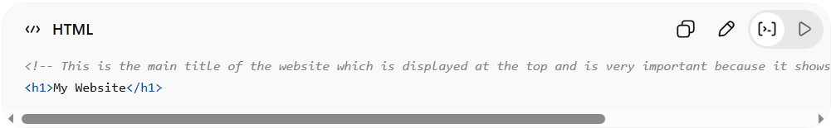
<!-- This is the main title of the website which is displayed at the top and is very important because it shows the name of the website to users -->
<h1>My Website</h1>
👉 Too long and obvious
✅ Good:
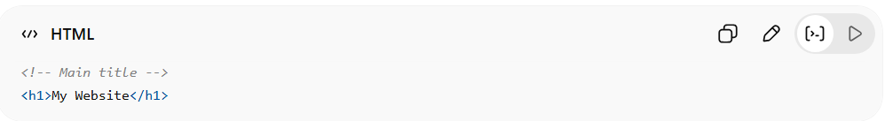
<!-- Main title -->
<h1>My Website</h1>
👉 Short, clear, and helpful

🚀 In short:
# Source: AI Source: Provided by: [Data Path: Persons Table -> ID Column: 1, Name_En Column: Motasem Essam] -> From: [ChatGPT] on [5/6/2026]
HTML Comments = invisible notes in HTML code used to explain or manage code without affecting the webpage.

